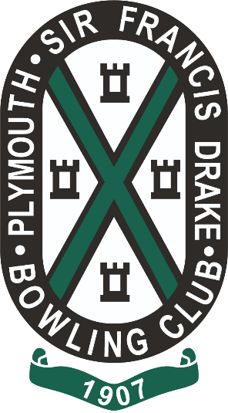

WINNERS OF CLUB
CHAMPIONSHIPS 2022
 | WINNER | Runner/s -up
MENS CHAMPIONSHIP | SAM ALLEN | Andy Prater
LADIES CHAMPIONSHIP | ALISON SPREADBOROUGH | Tracy Prater
MENS CHAMPION RUNNER UP | ANDY PRATER | -
LADIES HANDICAP | GILL GRANTHAM | Barbara Allen
MENS HANDICAP | SAM ALLEN | Andy Prater
LADIES UNBADGED SINGLES | JANE ROSE | Tracy Prater
MENS UNBADGED SINGLES | BILL GRANTHAM | Terry Rose
LADIES PAIRS | JANE ROSE & BARBARA ALLEN | C Blackwell & A Spreadborough
MENS PAIRS (Victory Cup) | SAM ALLEN & MIKE SKINNER | S Blackwell & P Chudley
MILLENNIUM SINGLES | EDDIE CORREY | Alison Spreadborough
LADIES 2 WOOD SINGLES | GILL GRANTHAM | Tracy Prater
MENS 2 WOOD SINGLES | TERRY ROSE | Bill Grantham
DEREK MARSHALL SINGLES | TONY WILLS | Nick Kilford
MIXED PAIRS | GILL GRANTHAM & EDDIE CORREY | T Prater & S Allen
MENS 2 WOOD PAIRS | ANDY BLACKWELL & EDDIE CORREY | J Haigh & B Drewitt
MIXED TRIPLES | T PRATER , D MATLOCK & R JOHNS | A Brewer, G Grantham & P Chudley
MENS OVER 70S | EDDIE CORREY | Paul Martin
ROUTLEDGE CUP | THE LADIES | The Men
LADIES CAPTAINS CUP | JANINE JAMES
MOST IMPROVED LADY | JANE ROSE
MOST IMPROVED MAN | BRENANN DREWITT
CLUB CAPTAINS CUP | TRACY & ANDY PRATER

WELL DONE TO ALL OF OUR WINNERS, NOT FORGETING THE RUNNERS UP AND ALL OF OUR MEMBERS WHO TOOK PART BOTH IN PLAYING AND HELPING OUT THROUGHT THE SEASON
THANK YOU

